Search application user’s guide

Search application allows you to search various types of documents for a specific term query. The output will be presented in a similar to Google’s manner in a list where each item represents a document. Each document will have highlighted fragments that contain the search term and a document’s title/id on top. By clicking on the result’s title(id) you will be able to see the original text. If you uploaded PDF or some other text file (not csv or tsv) your default program used to open files of that format will open it upon a click (eg Adobe Acrobat for PDF files).
When setting the parameters for search, you can enable the application to produce a csv file with results and later download it. Results file will contain id of the document and a score which reflects document’s relevance to the search query.

Running the application

The way for you to start the application depends on the operating system you use.
The most common way is to open a command line tool, change into the directory where the jar file is and type in java -jar name_of_the_file.jar
On some platforms double clicking the icon will do the job for you. If you run into problems please search online for a solution as it is platform dependent.

Once you’ve started the application, a graphical user interface appear. Some of the buttons and options will not be available due to the sequence of events that need to take place when preparing the application for search.
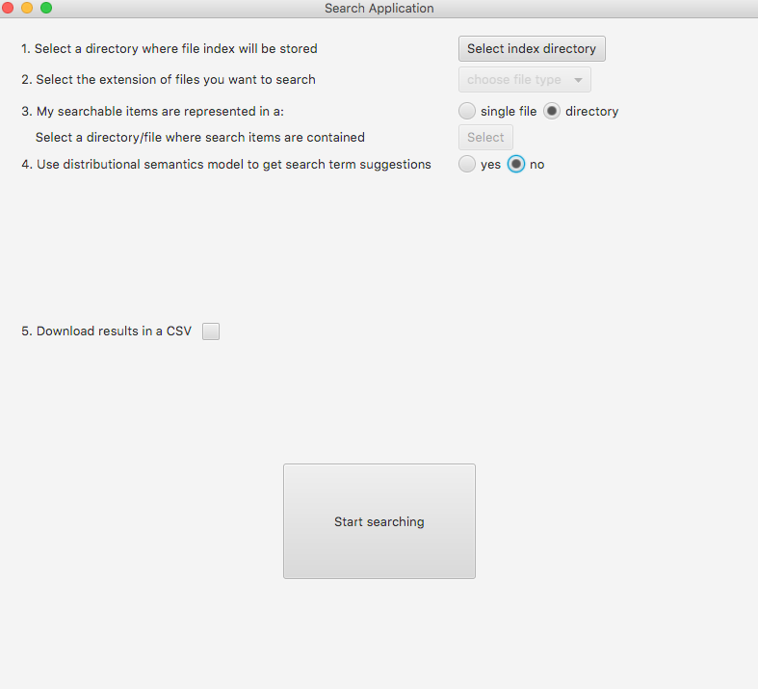
Entry screen of the application

Preparing to search
The first thing you are required to do is to point the software to a directory where the indices of your searchable files will be kept. It is preferrable that a directory is initially empty. Once you tell the program where the files you want to search are, index directory will start being filled with index files. Please do not erase any files from the index directory while searching as this directory is essential and that’s what enables the software to work correctly.
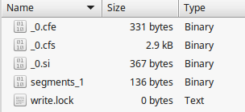
Example contents of index directory

After the index directory is selected, you’ll be prompted to select the file type (extension) that you want to search. All your files must be of the same extension, eg you cannot search csv and pdf files at the same time. If you pick to search a csv file, you’ll be asked to enter 2 additional files: the header of the id of the document and the name of the column that contains the actual text that you want to search in.
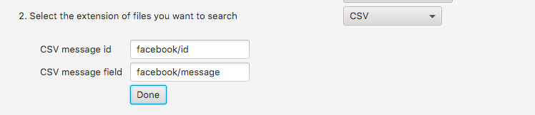
Additional paramters that needs to be set when searching a csv file

As an example csv that we want to index:
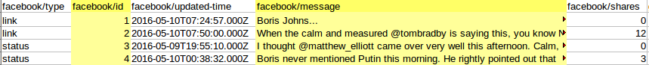
Example csv file with highlighted headers

Here 2 headers and their corresponding columns are selected as an example of what is required to enter when searching in a .csv. The most important is to point to the correct column that represents a message text (content) as id field can be represented by anything. Do not forget to press “Done” after you’ve entered the field names.

Next you are asked to select whether your files are represented in a single file or a directory. It is assumed that when you’re working with PDF or other text files they will be located in a separate directory. On the contrary, csv and tsv files would most likely contain a dataset in a single file.
The next step is to select the location of your file(s). Once you’ve done it, the software will start indexing the files which will take some time depending on the size of the files. Please be patient at this point.

At this point you are already set up to perform search, all next steps are optional but can be useful if you want to get the most out of the application.

Optional setup steps
You can choose to upload a distributional semantics model generated using word2vec software. Uploading the model enables the app to offer you terms for search expansion based on the data contained in the model.
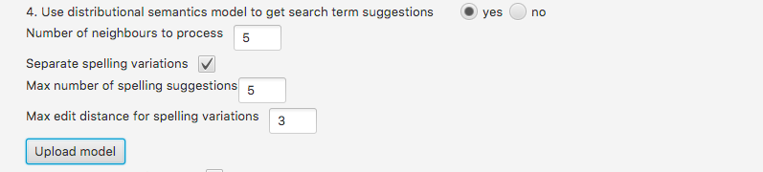
Configurable parameters for model upload

If you decide that you want to upload a model, you will be asked to enter a number of neighbours to process - this is the number of suggestions that will be generated. The smaller number you choose, the closer to the original term the suggestion will be and the faster the software will work.
Another option is to separate spelling variations from all other suggestions which is handy when you want to see what kind of spelling people use when referring to the same term as you used in your search query. For example, if you wanted to search for “common”, search results for this term will be presented and if the model reveals that sometimes people misspel this word as “comon”, you will be able to search again including the other spelling. (same would go for “theatre/theater” and so on). The way spelling suggestions are generated is based on the edit distance from the original query term. If you set the edit distance to be quite high, you will get a lot of “noisy” spelling suggestions. In order to get spelling variations closer to the original term, it would be recommended to set edit distance parameter between 1 and 3.

One other option to select is whether you would like to download results as a csv file. This can be useful when you want to get to the results at some later point in time rather then go through them all at a time.

Once you’ve set up the application ready for search, “Start searching” button should become enabled - the new screen will appear when you click on it.

Performing search

Once on the search screen, you will be presented with an entry field and a search button. Enter your search query in the field and click on “search”.
Search entry point

If you have previously uploaded a distributional model, you will see suggested terms for your query as well as actual search results.
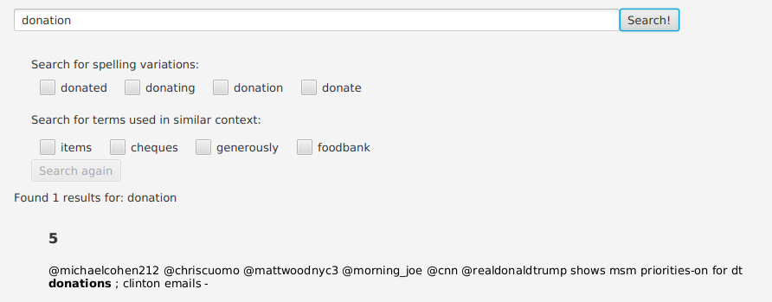
Displaying search results

You can click on the id of the document and the full text preview will be presented to you
Document text preview

If there are no results found, you will see a following screen where you can to pick terms for a new search which might actually bring some results.

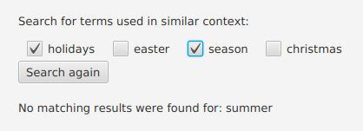
Offering term suggestions where no matching results were found for the original term

There are 2 buttons at the bottom on the screen that allow you to download the csv as results of your search and to go back to the setup screen and reset search parameters if necessary.
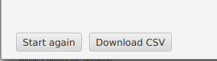
Control buttons at the bottom of the search screen

The csv file with results will be downloaded into the current directory where you are running the software. The name of the file is: search_results_for + your entered search query.
If the original file you’ve uploaded was in a csv format, the outcome file will be a copy of a csv with the new field (score) appended and only the rows that matched the results will be present.
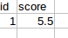
Example csv file with results

